School: | St Mary’s Catholic Primary School, Marnhull
SENCO: | Sharon Betts
Date of report: | July 2025
SEND Governor: | Nicola Denham

SEND profile for last 12 months

Total Number on Roll | 76 (89) | % Boys with SEND | 13% (10) | % Girls with SEND | 12% (9)
Number of SEND Register | 19 | Number at SEND Support | 16 | Number with EHCPs | 3
% on SEND Register | 25% | % of pupils at SEND Support of SEND register/whole school | 84%  21% | % of pupils with an EHCP of SEND register/whole school | 16%  3.9%
Number of PP Children with SEND | 5 | % of PP pupils with SEND of SEND register/whole school | 26%  7% | % of CLA with SEND | 0

- 19 (25%) pupils on SEN register, including 3 pupils with Education Health and Care Plans
- 5 pupils are also in receipt of pupil premium

Pupils receiving additional SEND support and/or have an Individual Support Plan in place.

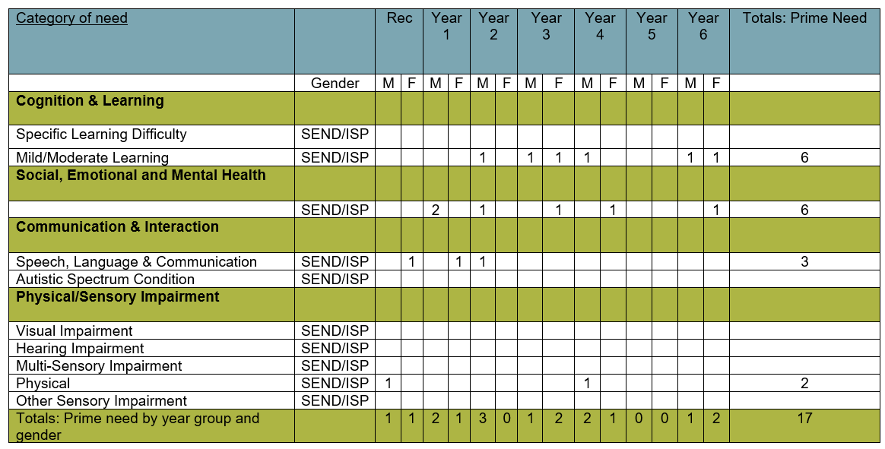

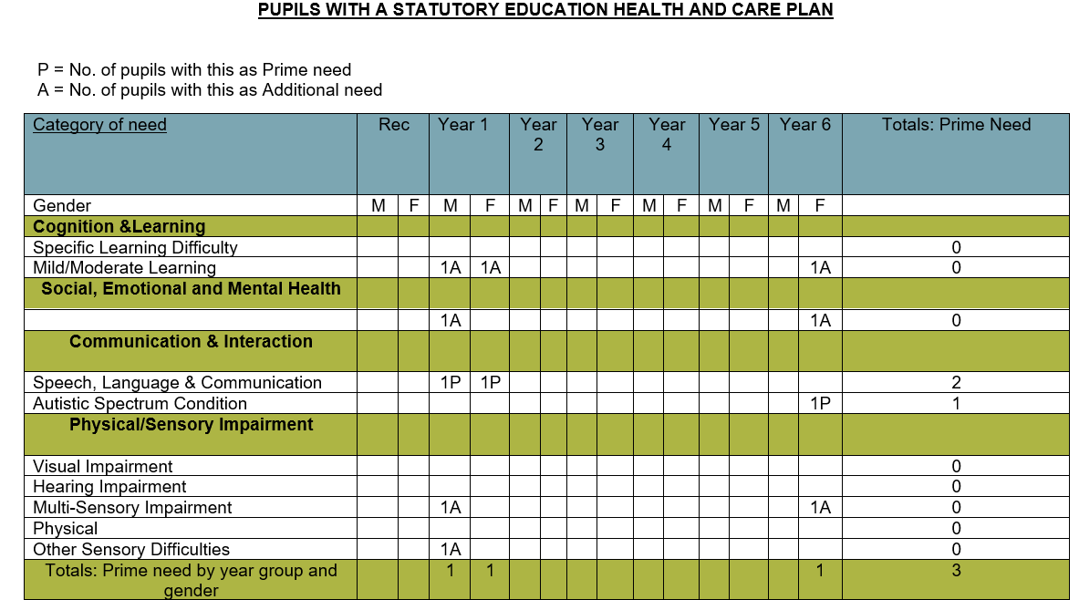
Overall quality of provision for pupils with SEND
Quality of education for pupils with SEND
- Ofsted May 2-23 reported:
  - Teachers ensure that learning is well structured to meet the individual needs of pupils.
  - Teachers adapt learning to enable pupils to access the full curriculum. They provide effective support for pupils with social and emotional difficulties. This helps these pupils to attend school more regularly and progress well through the curriculum.
- All pupils study a full and broad curriculum, including in Year 6 and those pupils with SEND.
- During the learning journey, a range of objectives in several curriculum subjects are addressed and adapted to meet the needs of pupils with SEND. They are considered and included in all aspects of learning and school life, whilst also being supported to increase their independence.
- Throughout lessons pupils with SEND are fully integrated and learning is scaffolded in ways to support their engagement. RWI, Power Maths, pathways to Writing approach to writing – all follow Rosenshine’s principles, through effective modelling, small chunks, I do, we do, you do. Etc
- There are high expectations for all learners and pupils with SEND have equality of access to qualified teachers. Quality First Teaching is our first intervention. TAs support learners across the ability groups so that all ability groups are taught by the class teacher.
- There are opportunities built in every week for teachers to work either 1-1 or in small groups with specific children, many of these are on SEND register – depending on needs at a given time.
- Transition is in place for moving to secondary school, with enhanced support in place for those pupils who need it. Transition for pupils within school moving from one teacher to the next is also in place – teachers meet to share knowledge and expertise of the pupils, opportunities for the teacher to meet with the pupils and if necessary this is enhanced.

Outcomes for pupils with SEND
- Data shows pupils with SEND are making progress over time.
Y1-6 SEND  Sum 21 | % @ ARE | % @ ARE+ | % Expected progress | % More than expected progress
R | 29 (5) | 6 (1) | 65 (11) | 0
W | 24 (4) | 6 (1) | 76 (13) | 0
M | 29 (5) | 0 | 65 (11) | 0
Y1-6 SEND
Sum 22
R | 33 (8) | 17 (4) | 83 (20) | 21 (5)
W | 33 (8) | 4 (1) | 79 (19) | 13 (3)
M | 50 (12) | 21 (5) | 79 (19) | 25 (6)
Y1-6 SEND
Sum 23
R | 36 (5) | 0 | 86 (12) | 36 (5)
W | 21 (3) | 0 | 92 (13) | 29 (4)
M | 43 (6) | 7 (1) | 86 (12) | 36 (5)
Y1-6 SEND
Sum 24
R | 42 (8) | 0 | 93 (14) | 20 (3)
W | 37 (7) | 0 | 93 (14) | 27 (4)
M | 58 (11) | 5 (1) | 93 (14) | 27 (4)
Y1-6 SEND
Sum 25
R | 40 (8) | 5 (1) | 100 (20) | 25 (5)
W | 25 (5) | 0 | 100 (20) | 10 (2)
M | 50 (10) | 0 | 100 (20) | 30 (6)

- 100% of pupils with SEND make at least expected progress from their starting points in Reading, Writing and Maths – due to our inclusive ethos, we have had several vulnerable children join us who are significantly behind with their learning. This continues to be a challenge for the school.

Effectiveness of leadership and management for SEND
- Ofsted May 2-23 reported:
  - Leaders have improved the curriculum so that it is broad and ambitious. They provide pupils, including those with special educational needs and/or disabilities (SEND), with the knowledge that they need to succeed.
  - Leaders are ambitious for pupils with SEND. They provide training for staff to ensure that they are skilled and knowledgeable about a range of SEND. Teachers adapt learning to enable pupils to access the full curriculum. They provide effective support for pupils with social and emotional difficulties. This helps these pupils to attend school more regularly and progress well through the curriculum.
- HT/SENDCo is an experienced SENDCo of 19 years in a previous school (1998-2017).
- HT/SENDCo visits classes regularly and observes pupils’ response to learning. HT/SENDCo teaches in Y3/4 for 0.4 of the week, and is therefore well placed to lead as a practising teacher.
- Book scrutinies are undertaken regularly and show adaptation through scaffolding, support and outcome.
- Professional dialogues occur around children’s learning.
- Pupil progress meetings take place termly.
- HT/SENDCo has termly planning meeting with Educational Psychologist and Specialist Teacher from Dorset.
- HT/SENDCo reviews registers at least termly following Pupil Progress meetings or upon meetings with parents or external agencies.

Personal development, behaviour and welfare of pupils with SEND
- Ofsted May 2-23 reported:
  - Pupils enjoy attending this inclusive school. They live out the school’s deep-rooted values of respect, compassion, forgiveness, and tolerance. They say this is a place where ‘we make lots of friends and everyone is accepting.’
  - Leaders have designed an effective personal development curriculum. Pupils grow to be reflective, caring and accepting of all. They develop a deep understanding of faith and celebrate religious and cultural differences. Leaders make use of opportunities to help pupils understand fundamental British values, such as discussing national elections.
  - Pupils behave well. Where low-level disruptions occur, staff give pupils clear instructions to refocus them on learning.
- Pupils with SEND are meaningfully involved in all aspects of school life alongside their peers. All children are given the opportunity to put themselves forward for leadership roles:
  - 2 pupils are on School Council
  - 2 pupils are Librarians
  - 3 pupils are on GIFT team
- Fixed term exclusions in 2024-5 were 0
SEN policy
SEND policy is a Trust-wide policy and was reviewed in September 2024.
SEN information report on school website
SEND Information report was reviewed in October 2024 and meets statutory requirements.
Statutory assessments
Access arrangements were made for several pupils who were eligible to have extra time and if necessary a 1-1 reader.
Staffing for SEND
Quality First Teaching is our first intervention. TAs support learners across the ability groups so that all ability groups are taught by the class teacher. We now have two ELSAs in place and they attend regular supervision.
Interventions
- Not many interventions in place:
  - RWI/Fresh Start for pupils in KS2 (data)
  - Beat Dyslexia
  - ELSA (discussions with ELSA).
  - Targeted SALT interventions
CPD for SEND
- ELSA has regular supervision.
- All staff delivering RWI have had training bespoke to their needs and continue to do so.
- All staff have had training on Emotional School Avoidance
- All staff have ongoing Trauma Informed Schools (TIS) training
- One member of staff is now a TIS practitioner
- HT/SENDCO attends termly Trust SENDCO Network meetings
Pupil voice
- Pupils actively contribute to their review meetings wherever possible and their views are reflected on paper with a trusted adult
- Pupils with SEND are represented throughout school groups as all pupils are given the opportunity to put themselves forward for leadership roles
  - 2 pupils are on School Council
  - 2 pupils are Librarians
  - 3 pupils are on GIFT team
Parent/carer voice
- As a small school, we know each and every child and family.
- Ofsted May 2-23 reported:
  - Parents rightly say that their children are safe and well cared for. They too feel supported by staff, who regularly communicate about their children and tell them how they can help with learning at home.
- Parents have opportunities to meet with class teacher at least termly
- Support plans shared with parents at least termly
External agencies
- Termly planning meetings with Dorset Educational Psychologist (EP) and Specialist Teacher
- Ongoing liaison with Speech and Language Therapist (SALT)
Are there any concerns regarding provision for pupils with SEND?
Accessing support out of county e.g. Somerset remains extremely challenging. Too often bureaucracy hinders supporting children who need it.

